COSC 336 - Introduction to Software Engineering
Fall 2026

UNIventory
Intelligent, AI-Powered Circular Campus Resource Exchange and Asset Life Cycle Management System

Phase 4 & 5: Design Document
Architecture and Detailed Design

Prepared by :
Section B1 | Group 7
Sinan Saleem - 100065899
Jesher Jebson - 100065908
Jessica John - 100065552

Prepared for :
Khalifa University
Instructor - Dr. Jamal Bentahar
Lab Engineers - Natnael Takele and Basima Kurungadan

Date : 26/10/2026

Design Overview
UNIventory will give Khalifa University one internal place to find reusable resources, agree accountable transfers and keep the same records through inspection, repair and final outcomes. This document turns the documented requirements baseline into an architecture and detailed design for implementation. The design uses a modular Django application, a separate worker running the same release, PostgreSQL with pgvector, protected evidence files and an AI gateway. Business modules own permissions, stock, approvals and official calculations. GPT-6 Astra supports classification, explanations, action advice, assistant interaction and report drafting. Text embeddings support meaning-based matching; the application computes the final weighted score. The pilot covers three departments and six resource categories. High and Medium requirements remain essential. Basic Arabic support is the planned Low-priority addition; bulk import, email notices, richer dashboards and numerical forecasting retain the extension status established in Phase 3. Sections 1-6 contain the architecture design. Sections 7-11 contain UML models, data design, component/deployment views, interface contracts and detailed AI/impact calculations. Figures are placed beside the decisions they explain. From the Phase 3 baseline the design preserves its role boundaries, 48-hour hold, independent approvals, partial-quantity handling and accepted-receipt rule. Numerical acceptance targets describe checks to run during implementation; they are not test results.

Design Area | Carried-Forward Commitment | Phase 3 Links
Access | KU SSO and Microsoft Authenticator; application roles and scopes checked on every protected operation. | FR-01–FR-04; NFR-08–NFR-14
Exchange | Request approval, approved publication, temporary holds, transfer commitment, dispatch and assigned receipt remain separate decisions. | FR-11–FR-36; BR-02–BR-10
Life Cycle | Inspection, maintenance, failed repair, donation, component recovery, recycling, retirement and disposal remain in scope after transfer. | FR-37–FR-47
AI Control | All five AI capabilities are required; users can use manual workflows. Advice cannot approve or change stock. | AI-01–AI-19; NFR-23
Quality Targets | Ordinary search/list p 95 <=2 s, 20 concurrent users, 1,000 assets; interactive AI <=60 s; background result/failure <=5 min. | NFR-01–NFR-04
Recovery | Daily encrypted backups, seven daily pilot versions, recovery point <=24 h and recovery time <=4 h. | NFR-17
Evidence | Recorded sources support financial and environmental figures. Unknown, zero, estimates and observed results remain distinct. | FR-50; SUS-01–SUS-10

Context Diagram
UNIventory is an internal resource exchange and asset life-cycle application. Its system boundary includes the website, domain logic, AI orchestration, stored records and reporting. University identity verification and external model execution remain outside that boundary. Physical collection, inspection, repair and disposal remain staff or contractor work; staff record their evidence in UNIventory. Figure A1 uses one process numbered 0 and no data stores. Four staff groups keep the drawing readable while retaining every Phase 3 role. The following table expands those groups. Campus User is the common role for sign-in, assistant help and notifications across all four groups. The grouping does not give a person the permissions of every role in that group.
External donation/recycling partners have no application accounts in the prototype. Internal staff record their approved contact and handover evidence. Procurement/finance evidence is entered by authorised staff; there is no live ERP integration. Email is an optional extension, so an email provider is not shown as a required external entity.

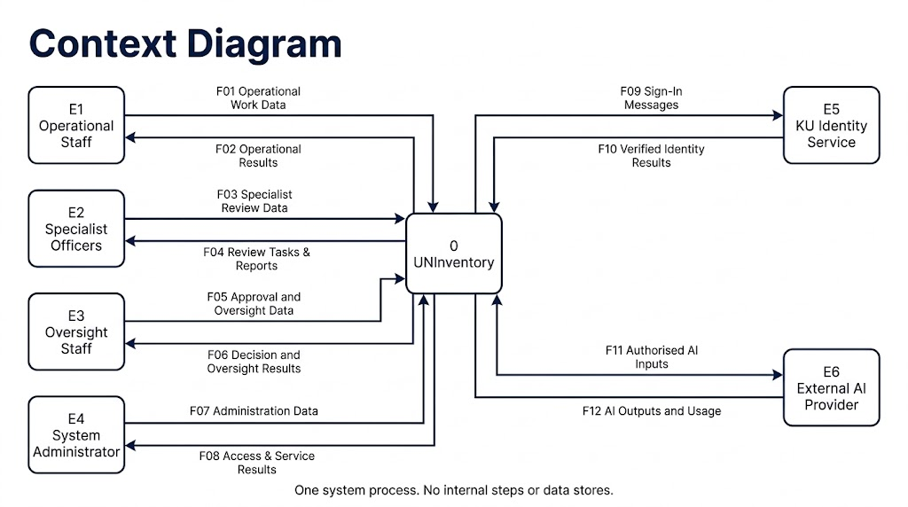
Figure A1

2.1 External Entities and Role Coverage
Entity | Included Roles or Service | Main Data Exchanged
E1 Operational Staff | Requester, Department Representative, Asset Custodian, Assigned Receiver, Maintenance Staff | Asset, need, transfer, service and final-outcome work; permitted results and notices.
E2 Specialist Officers | Procurement Officer, Finance Officer, Sustainability Officer | Procurement/finance/sustainability evidence; specialist tasks and reports.
E3 Oversight Staff | Authorised Approver, University Management, Auditor | Independent decisions and oversight filters; cases, audit and management results.
E4 System Administrator | System Administrator | Approved access/reference/configuration work; service and access results.
E5 KU Identity Service | Existing university SSO and Microsoft Authenticator | Sign-in messages and verified identity/failure results.
E6 External AI Provider | Approved flagship model and embedding API | Minimum authorised model inputs; outputs and usage/status metadata.

2.2 Context Data-Flow Dictionary
Flow | Direction | Data Package
F01 Operational Work Data | E1 → P0 | Asset/listing details; needs and selections; dispatch and receipt evidence; service/final-action evidence; assistant queries; permitted filters and session actions.
F02 Operational Results | P0 → E1 | Validated records; suggestions; request/reservation/transfer/service states; permitted history; assistant answers; reports and notices.
F03 Specialist Review Data | E2 → P0 | Procurement and finance evidence; sustainability factors and validation; assigned specialist reviews; report filters; assistant/session data.
F04 Review Tasks and Reports | P0 → E2 | Assigned evidence packs; validation outcomes; permitted financial/impact reports; assistant answers and notices.
F05 Approval and Oversight Data | E3 → P0 | Assigned approval decisions; report/audit filters; discrepancy evidence; assistant/session data.
F06 Decision and Oversight Results | P0 → E3 | Review queues and decision records; management reports; protected audit exports; assistant answers and notices.
F07 Administration Data | E4 → P0 | Role/scope/reference changes; approved configuration values; recovery/service requests; assistant/session data.
F08 Access and Service Results | P0 → E4 | Access/configuration outcomes; permitted service status, recovery evidence and notices; assistant answers.
F09 Sign-In Messages | P0 → E5 | University sign-in redirect/challenge context, logout and approved protocol messages; no stored university password or Authenticator code.
F10 Verified Identity Results | E5 → P0 | Verified stable identity and permitted attributes, or failure/cancellation. Local UNIventory roles remain application-owned.
F11 Authorised AI Inputs | P0 → E6 | Task type; minimum permitted text/image/document content or embeddings input; structured schema and approved model identifier.
F12 AI Outputs and Usage | E6 → P0 | Model output, embedding or draft; provider/model identifier, usage, status and error metadata.

Data Flow Diagrams
Level 1 decomposes process 0 into seven numbered processes. The figures are complementary sheets of the same Level 1 model. Figure A2 shows the external boundary flows; Figure A3 shows the exchanges between internal processes; A4 to A6 show the persistent data flows. Repeated process/store IDs identify the same logical process or store. They are not additional copies of a database or extra services. Process 1.0 authenticates, authorises and routes work. It validates server-derived identity and permissions before dispatching a packet to its responsible domain process. It does not approve a transfer, change stock, certify safety or calculate an impact. Each domain process validates its own record version and business state. This prevents the entry process from becoming a second implementation of every business rule.
A flow label names data, not a control instruction. Decisions and timing belong in the activity, sequence and state models. Processes read and write stores; no external entity accesses a store directly and no store sends data directly to another store. Every process has an input and output; every store is read and written. The full machine-readable registry keeps all 12 boundary, 20 process and 49 store flows.

3.1 Level 1 Processes
Process | Responsibility | Phase 3 Links
1.0 Authenticate and Route Work | Authenticate the university identity; check local role, department and assignment; maintain approved role/reference configuration; route scoped work to its owner and return permitted results. No stock, approval, service or impact decision is made here. | FR-01–FR-04; FR-02; NFR-08–NFR-14
2.0 Manage Assets and Listings | Register assets and portions, maintain controlled records, prepare release/publication, validate attachments, expose inventory and retain life-cycle history. | FR-05–FR-14; FR-09–FR-10
3.0 Manage Requests and Reservations | Validate needs, search permitted stock, request recommendations, create atomic holds and track expiry, outstanding demand and reviewed choices. | FR-15–FR-25; AI-03–AI-06
4.0 Manage Approvals and Transfers | Route stage decisions, enforce independent approval, commit held quantities, record dispatch/receipt and reconcile discrepancies exactly once. | FR-26–FR-36
5.0 Manage Service and Final Actions | Record inspections, maintenance, verification and failed work; manage approved donation, recovery, recycling, retirement and disposal with physical evidence. | FR-37–FR-47; AI-07–AI-08
6.0 Produce AI Advice and Answers | Validate scoped work, prepare permitted model inputs, call the gateway, compute/explain ranking, validate structured outputs, retain provenance and return useful results or a safe fallback. It cannot approve or change stock. | AI-01–AI-19
7.0 Produce Reports and Notifications | Calculate evidence-based indicators and report snapshots, request narrative drafts, deliver in-app notices and expose permitted audit/report views. | FR-48–FR-56; AI-09–AI-10; SUS-01–SUS-10

3.1.1 Logical Stores and ER Model Coverage
Store | Logical Records | Storage Interpretation
D1 Users Roles and Reference Records | Department, AppUser, Role, UserRole, Category, Location | Related PostgreSQL tables; the grouped DFD store is not one oversized database table.
D2 Assets Listings and Inventory Records | Asset, AssetPortion, AssetEvent, Listing | Related PostgreSQL tables; the grouped DFD store is not one oversized database table.
D3 Requests and Reservations | ResourceRequest, Reservation | Related PostgreSQL tables; the grouped DFD store is not one oversized database table.
D4 Approvals and Transfers | WorkflowCase, ApprovalStage, ApprovalDecision, Transfer, Consignment, ReceiptEvent, ReceiptAllocation | Related PostgreSQL tables; the grouped DFD store is not one oversized database table.
D5 Inspections Service and Final Actions | Inspection, MaintenanceRecord, FinalAction, FinalActionExecution | Related PostgreSQL tables; the grouped DFD store is not one oversized database table.
D6 AI Runs Recommendations and Model Records | ModelVersion, AssetEmbedding, AIRun, MatchRecommendation, RecommendationReview | Related PostgreSQL tables; the grouped DFD store is not one oversized database table.
D7 Cost Impact and Report Records | CostEntry, AvoidedPurchase, SustainabilityImpact, ReportSnapshot, SnapshotImpact | Related PostgreSQL tables; the grouped DFD store is not one oversized database table.
D8 Audit Events Notifications and Work Items | Notification, AuditLog, WorkItem, OperationReceipt | Related PostgreSQL tables; the grouped DFD store is not one oversized database table.
D9 Protected Evidence Files | Attachment, Protected Object/File Bytes | Protected object/file storage with Attachment metadata

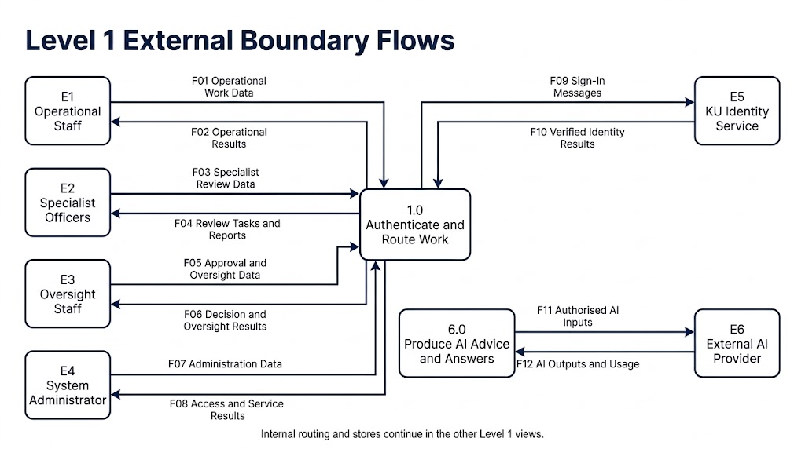
3.1.2 Figure A2 - Level 1 External Boundary Flows
Figure A2

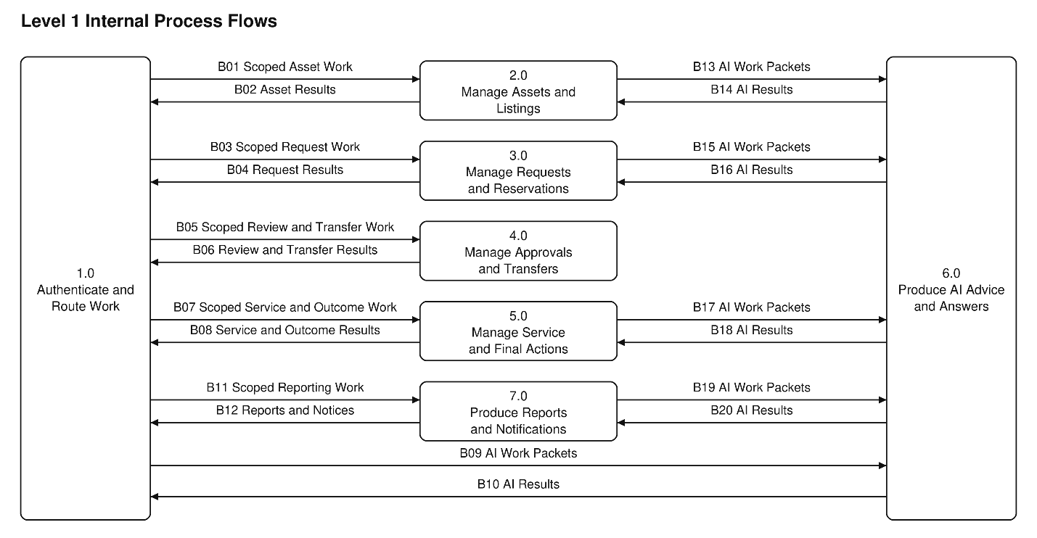
3.1.3 Figure A3 - Level 1 Internal Process Flows
Figure A3

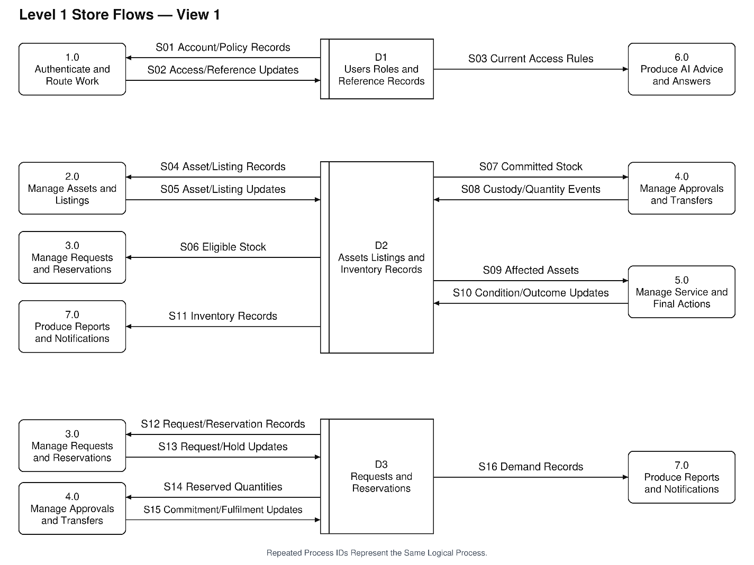
3.1.4 Figure A4 - Level 1 Store Flows View 1
Figure A4

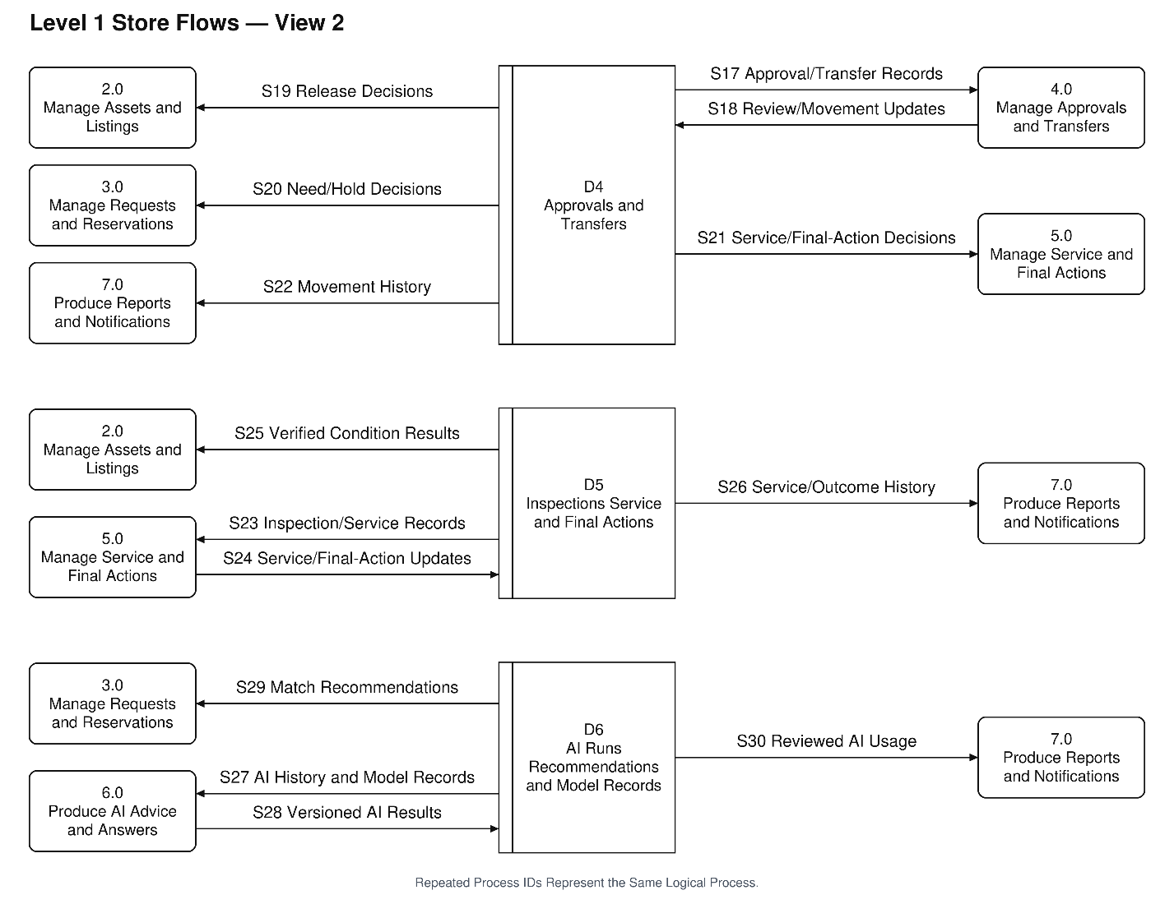
3.1.5 Figure A5 - Level 1 Store Flows View 2
Figure A5

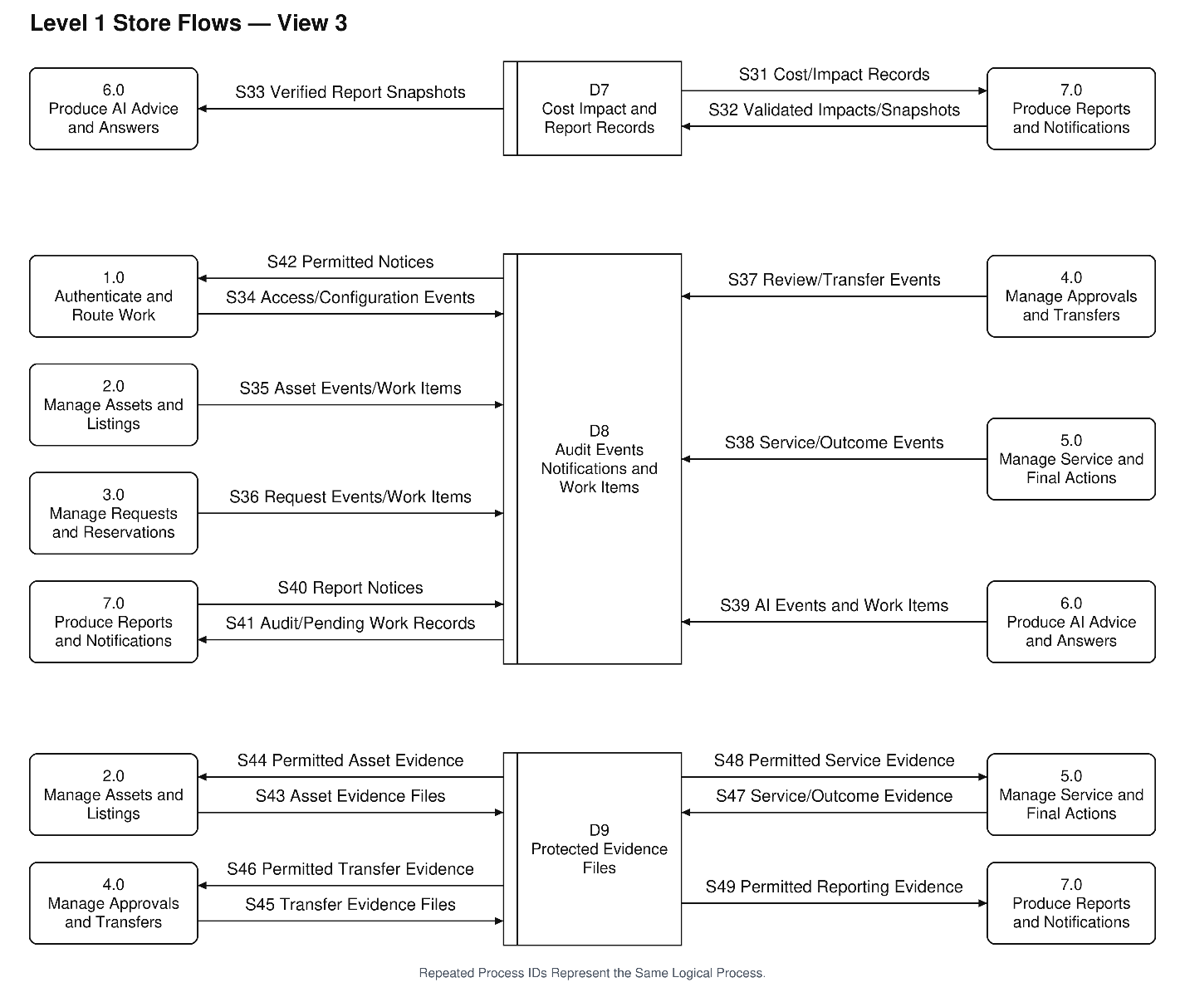
3.1.6 Figure A6 - Level 1 Store Flows View 3

Figure A6

3.1.6 Context to Level 1 Balance
Context Flow | External Entity | Direction | Level 1 Endpoint | Result
F01 Operational Work Data | E1 | Inbound | P1 | Exact name and direction retained
F02 Operational Results | E1 | Outbound | P1 | Exact name and direction retained
F03 Specialist Review Data | E2 | Inbound | P1 | Exact name and direction retained
F04 Review Tasks and Reports | E2 | Outbound | P1 | Exact name and direction retained
F05 Approval and Oversight Data | E3 | Inbound | P1 | Exact name and direction retained
F06 Decision and Oversight Results | E3 | Outbound | P1 | Exact name and direction retained
F07 Administration Data | E4 | Inbound | P1 | Exact name and direction retained
F08 Access and Service Results | E4 | Outbound | P1 | Exact name and direction retained
F09 Sign-In Messages | E5 | Outbound | P1 | Exact name and direction retained
F10 Verified Identity Results | E5 | Inbound | P1 | Exact name and direction retained
F11 Authorised AI Inputs | E6 | Outbound | P6 | Exact name and direction retained
F12 AI Outputs and Usage | E6 | Inbound | P6 | Exact name and direction retained

3.2 Level 2 AI Process
We decompose 6.0 Produce AI Advice and Answers because it crosses the external-provider boundary and supports every AI function. An error here could expose a restricted record, present unsupported advice or leave a user waiting. The decomposition makes privacy checks, output validation, version recording and failure results visible in one place.

6.1 validates the task, active actor scope and permitted purpose. 6.2 prepares the minimum authorised evidence and the selected model/prompt/profile version. Asset vectors are prepared

ahead of use; matching uses the current permitted candidate set. 6.3 calls the provider through the outbound gateway. 6.4 checks schema, IDs, evidence, hard eligibility and the deterministic score/explanation structure. 6.5 records the run, usage, result versions and final status for every path, including denied work, unavailable services and invalid or weak output. Failed runs keep a null result reference; a denied attempt records only safe audit metadata and no restricted input. 6.6 then returns a result, a review-needed result or a clear manual fallback to the calling process.
Classification, matching, sustainable advice, assistant answers and narrative reports are task types within this orchestration. The provider has no database credentials and cannot execute an approval or inventory change. Stored inputs and outputs are rechecked against current record versions before a user acts. A similarity score is not a calibrated probability; evidence status and missing facts remain separate.
The 17 parent boundary flows are retained in the Level 2 boundary table. Identical AI Work Packets and AI Results labels from several calling processes are grouped in the figure by their original B-identifiers. The grouping preserves each named caller and return destination; it does not invent a new external actor.

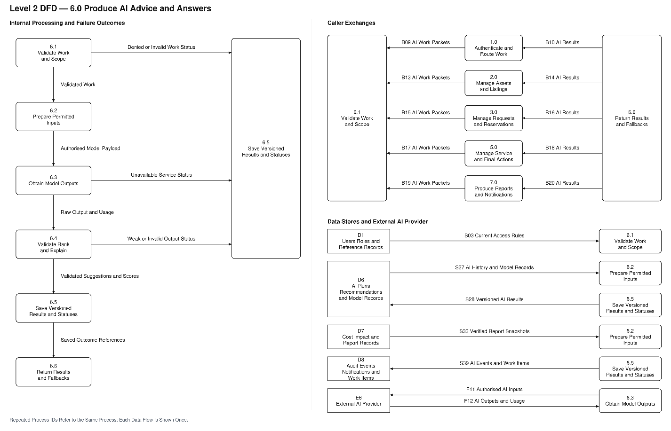
3.2.1 Level 2 AI DFD
Figure A7

3.2.2 Level 1 to Level 2 Balance
Parent Flow | Parent Endpoint | Level 2 Endpoint | Direction
B09 AI Work Packets | P1 → P6 | 6.1 Validate Work and Scope | Into 6.0
B10 AI Results | P6 → P1 | 6.6 Return Results and Fallbacks | Out of 6.0
B13 AI Work Packets | P2 → P6 | 6.1 Validate Work and Scope | Into 6.0
B14 AI Results | P6 → P2 | 6.6 Return Results and Fallbacks | Out of 6.0
B15 AI Work Packets | P3 → P6 | 6.1 Validate Work and Scope | Into 6.0
B16 AI Results | P6 → P3 | 6.6 Return Results and Fallbacks | Out of 6.0
B17 AI Work Packets | P5 → P6 | 6.1 Validate Work and Scope | Into 6.0
B18 AI Results | P6 → P5 | 6.6 Return Results and Fallbacks | Out of 6.0
B19 AI Work Packets | P7 → P6 | 6.1 Validate Work and Scope | Into 6.0
B20 AI Results | P6 → P7 | 6.6 Return Results and Fallbacks | Out of 6.0
F11 Authorised AI Inputs | P6 → E6 | 6.3 Obtain Model Outputs | Out of 6.0
F12 AI Outputs and Usage | E6 → P6 | 6.3 Obtain Model Outputs | Into 6.0
S03 Current Access Rules | D1 → P6 | 6.1 Validate Work and Scope | Into 6.0
S27 AI History and Model Records | D6 → P6 | 6.2 Prepare Permitted Inputs | Into 6.0
S28 Versioned AI Results | P6 → D6 | 6.5 Save Versioned Results and Statuses | Out of 6.0
S33 Verified Report Snapshots | D7 → P6 | 6.2 Prepare Permitted Inputs | Into 6.0
S39 AI Events and Work Items | P6 → D8 | 6.5 Save Versioned Results and Statuses | Out of 6.0

System Architecture
We choose a modular monolith with clear business modules and internal layers (Figure B1). Django serves the interface and application API. PostgreSQL holds transactional records and the exact pgvector comparisons for the 1,000-asset pilot. A worker runs the same code package for durable background jobs. The application and worker use one versioned codebase; a worker process does not turn the design into microservices. Business modules own their rules and expose named service methods. A transfer can call inventory and request services inside one database transaction, but it cannot make an unreviewed direct state edit. Shared records such as WorkflowCase, WorkItem and OperationReceipt provide approval anchoring, durable work and duplicate protection without moving responsibility into a generic helper.
The outbound AI gateway validates and sends permitted payloads to the selected flagship model and embedding endpoint. The local orchestration records AIRun and ModelVersion information. Every provider call runs in the local worker. The web app commits a durable job and polls/returns its result; a browser never receives the provider secret. Interactive waiting and queued notification are application patterns, not provider background modes. The gateway has no direct database credentials or business authority.
Embeddings use text-embedding-3-large at 3,072 dimensions. For the pilot, exact cosine comparison runs over the already permission-filtered candidate set, with explicit model/dimension version checks. This avoids an incompatible approximate-vector index and makes correctness easier to inspect at the stated data size. A future approximate-index decision must preserve filtering, dimensions and measured relevance.
Notification and AI jobs are recorded with their source transaction in a durable WorkItem/outbox. A worker claims pending work, applies bounded retries and records the outcome. OperationReceipt keys and business constraints ensure that a repeated delivery cannot create another receipt, approval or quantity movement. User-visible notices are built from committed events, not from an AI claim that an action happened.

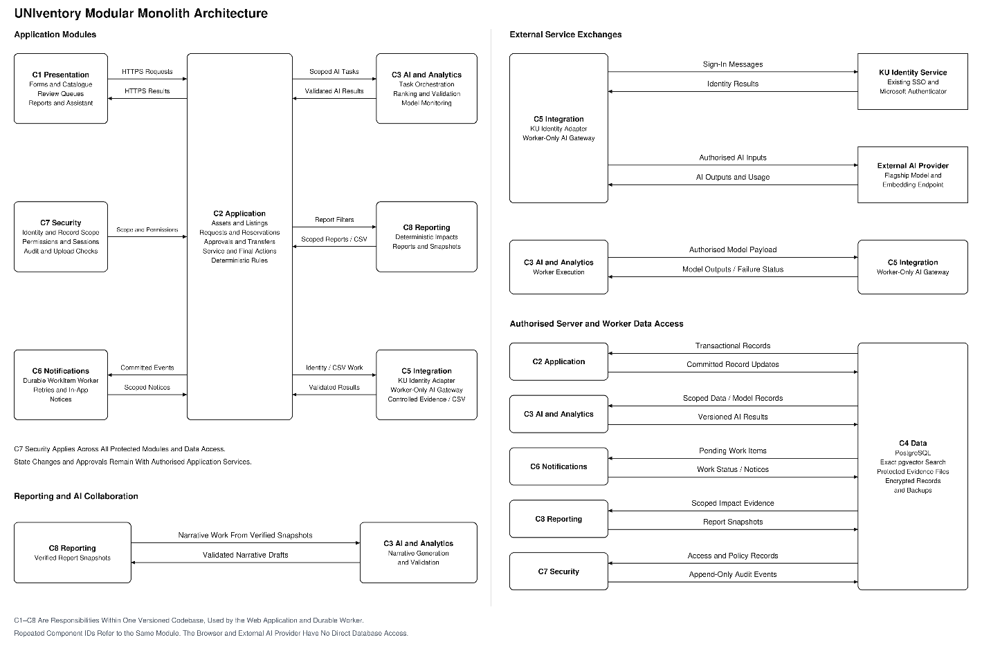
Figure B1

4.0.1 Architecture Components
Component | Responsibility and Boundary | Communication
C1 Presentation | Role-specific forms, catalogue, review queues, reports and assistant preview. It displays evidence and asks for human confirmation. | HTTPS forms/JSON to C2; no direct database or provider access.
C2 Application | Identity context, asset/listing, request/reservation, approval/transfer, service/final-action domain services. Owns deterministic state changes. | Validated service calls within one transaction; C3 requests; C4 records; C6 outbox events.
C3 AI and Analytics | AI orchestration, classification/matching/action/assistant/report adapters, score factors, structured validation and model monitoring. | Scoped work packets from C2/C8; outbound inference through C5; versioned AIRun records in C4.
C4 Data | PostgreSQL transactional records and exact pgvector storage; protected attachment bytes; encrypted backup copies. | Only authorised server/worker data access; no browser/provider credentials.
C5 Integration | KU identity adapter and outbound AI gateway. Manual procurement/finance evidence and UTF-8 CSV exports remain controlled interfaces. | HTTPS identity/provider protocols; bounded timeouts and validated schemas.
C6 Notifications | Durable WorkItem claims, retry status and in-app notices after committed business events. Optional email remains outside essential delivery. | Transactional outbox inputs; scoped notice results through C2/C1.
C7 Security | Authentication context, permission and record-scope checks, upload validation, secret handling, session control and append-only audit service. | Applied at entry, domain service, retrieval, attachment/export and assistant tool boundaries.
C8 Reporting | Deterministic operational reports, evidence-based sustainability calculations and immutable report snapshots; optional narrative draft over a snapshot. | Filtered reads from C4; narrative task to C3; scoped reports/CSV to C1.

4.1 Architecture Decision Records

4.1.1 ADR-01 Architecture Style
Decision Item | Design Record
Phase 3 Drivers | FR-21–FR-36; FR-54–FR-55; NFR-15; NFR-24
Options | Modular monolith with one database and a worker from the same code package. / Service-oriented design with an independently deployed AI application and network contracts.
Choice and Reason | We choose the modular monolith because the small team can keep stock, approvals and receipt changes in one transaction while still isolating the AI gateway and domain rules.
What We Give Up | Independent deployment and technology choices for every business module. A separately deployed service can be extracted later only with a measured need.
Verification | Architecture dependency checks; one failed receipt transaction leaves no partial stock/history update; manual workflows complete during provider outage.

4.1.2 ADR-02 Vector Storage and Search
Decision Item | Design Record
Phase 3 Drivers | AI-03–AI-06; NFR-01; NFR-09; NFR-22
Options | PostgreSQL plus pgvector, exact search over the scoped pilot candidates. / A separate vector database or approximate index with separate data synchronisation.
Choice and Reason | We choose exact scoped PostgreSQL/pgvector search because the pilot has 1,000 assets and permissions, record versions and vectors can be checked together. The embedding dimension is recorded as 3,072.
What We Give Up | Approximate retrieval throughput at much larger scale. We accept that trade-off and retain a measured migration path rather than claiming an unnecessary index.
Verification | Reject mismatched model/dimension records; time the permitted candidate search; test that excluded records never appear in counts, previews or assistant retrieval.

4.1.3 ADR-03 Durable Background Work
Decision Item | Design Record
Phase 3 Drivers | FR-23; FR-52–FR-55; AI-18–AI-19; NFR-03–NFR-04
Options | Database WorkItem/outbox records committed with the originating business event. / Direct best-effort notification and provider calls from the business request.
Choice and Reason | We choose durable local jobs because a server retry or provider failure must not lose a required notice or repeat a stock transaction. Workers use idempotent operation keys and bounded retry metadata.
What We Give Up | The apparent simplicity of one synchronous request; job claiming, retries and recovery need explicit code and monitoring.
Verification | Stop a worker after commit, restart it, and verify one eventual notice/result and no duplicate inventory or approval effect.

4.1.4 ADR-04 Human Control of AI Results
Decision Item | Design Record
Phase 3 Drivers | AI-02; AI-08; AI-12–AI-18; FR-28–FR-30
Options | Embed explicit AI review in the ordinary classification, match, service, assistant and reporting forms, followed by normal workflow approvals. / Use a separate central AI review queue before returning accepted suggestions to their normal business workflow.
Choice and Reason | We choose review within the ordinary task forms because staff can compare advice with the current asset, need, evidence and action without moving between queues. Normal domain validation and approval still apply; the model cannot authorise release, safety, ownership change or spending.
What We Give Up | One central screen for bulk AI review across all task types. Review remains close to each task, with common monitoring records and oversight reports.
Verification | Inject an apparently confident unsafe suggestion and confirm that it cannot approve or execute an action. Verify that assistant request creation needs an explicit preview confirmation and still enters normal approval.

4.1.5 ADR-05 Presentation Technology
Decision Item | Design Record
Phase 3 Drivers | IF-01–IF-03; NFR-18–NFR-21; NFR-24
Options | Django templates with progressive JavaScript and selected JSON endpoints. / A separate single-page frontend with a second routing/state layer.
Choice and Reason | We choose server-rendered forms with progressive enhancement because the same validation and role checks can serve the normal task forms without a second application release.
What We Give Up | A richer client-only application shell and more local state between pages.
Verification | Keyboard/mobile task review; all normal forms work when an optional assistant call fails.

4.1.6 ADR-06 AI Output Contracts
Decision Item | Design Record
Phase 3 Drivers | AI-14–AI-19; NFR-09; NFR-23
Options | Task-specific structured output schemas with application post-validation. / Free-text responses parsed into domain fields by application code.
Choice and Reason | We choose structured schemas and post-validation because required fields, evidence references and source versions can be checked before a suggestion is shown. The gateway handles refusal and incomplete output separately.
What We Give Up | Unrestricted response formats; each task needs a maintained schema and validation rules.
Verification | Inject unknown IDs, extra fields, stale versions, a refusal and incomplete content. Each produces a recorded safe status without a stock or approval change.

4.1.7 ADR-07 Notification Delivery
Decision Item | Design Record
Phase 3 Drivers | FR-52–FR-55; NFR-15; NFR-23
Options | Transactional outbox with a retrying worker. / Send each notice while the business request is still committing.
Choice and Reason | We choose the outbox because a delivery failure must not undo a valid receipt or repeat it.
What We Give Up | Notices may arrive after a short delay rather than inside the original request.
Verification | Commit a transfer while notice delivery fails; one later notice appears without another stock movement.

5 AI Services
AI functions share one gateway, but they remain separate tasks with different schemas and failure paths. The gateway prepares the minimum authorised input, records versions, reserves the maximum permitted call spend, calls the approved model and validates the response before returning a suggestion.

Pattern A means ask and wait. Pattern B computes an embedding ahead of later searches. Pattern C queues work and notifies the user. All provider calls execute in the local worker. For Pattern A the browser waits by polling the job result within its 60-second deadline; the web process does not call the provider or hold an ordinary page worker open. Queued work runs in UNIventory’s worker; it does not depend on a provider-hosted conversation or background job.
The selected reasoning model remains gpt-6-astra. The registry records the actual returned model identifier and snapshot when exposed. Embeddings use text-embedding-3-large with 3,072
dimensions. Vectors are kept with their model/dimension/input-hash profile; incompatible profiles are never compared.

5.1 Classification
Item | Service Design
Pattern | A
Reason and Inputs | A custodian is editing a record and can continue manually. Inputs are the permitted title, description, structured fields and readable selected evidence.
Time Limit | 45 s provider budget inside the 60 s interaction deadline.
When Unavailable | Return manual category/tag fields. Preserve entered values; no partial AI field is saved.
When Evidence Is Weak | Show category, tags, proposed description, evidence coverage and missing fields. A custodian accepts, edits or rejects the suggestion; an image never verifies safety.
Phase 3 Links | AI-01–AI-02; AI-14–AI-18

5.2 Embedding and Semantic Retrieval
Item | Service Design
Pattern | B; request embedding uses A
Reason and Inputs | Asset changes create an outbox job; its embedding is reused. A request vector is computed for its current revision and embedding profile within the matching job; it is not a separate permanently cached request table. Exact cosine retrieval runs only over current, permitted, eligible candidates.
Time Limit | Asset refresh result/failure within 5 min. A request embedding uses the shared 60 s interaction deadline.
When Unavailable | Use keyword and deterministic compatibility search. Mark an absent/stale vector; do not compare it as current.
When Evidence Is Weak | Insufficient critical specifications prevent a confirmed match. Low supporting coverage produces Needs Review. No suitable result is valid.
Phase 3 Links | AI-03–AI-06; AI-17–AI-18

5.3 Ranking and Explanations
Item | Service Design
Pattern | Local deterministic score; A for prose
Reason and Inputs | The application scores stored factors using ranking profile RP-1. Astra may explain that result, but cannot replace the arithmetic or eligibility filter.
Time Limit | Score and search are measured separately from AI latency. Optional explanation call uses the remaining 60 s deadline.
When Unavailable | Show the rule-filtered keyword list and actual facts. If semantic input is absent, omit the AI score rather than fabricate one.
When Evidence Is Weak | Keep rank score separate from evidence status. Explain partial supply, factors and missing inputs; the requester chooses an item without obtaining stock yet.
Phase 3 Links | AI-04–AI-06; BR-04–BR-09

5.4 Sustainable Action Advice
Item | Service Design
Pattern | C
Reason and Inputs | A responsible user requests a comparison of reuse, transfer, repair, refurbishment, donation, recovery, recycling, retirement and disposal. Each option first passes the action-specific rules.
Time Limit | Terminal result/failure within 5 min of submission.
When Unavailable | Record No New Advice and retain the normal inspection/final-action screens. Do not rerun or execute a previous action.
When Evidence Is Weak | Mark unsupported comparisons Needs Review or Insufficient Evidence and ask for the missing inputs. A person decides; separate approval and physical evidence remain required.
Phase 3 Links | AI-07–AI-08; FR-37–FR-47

5.5 Assistant
Item | Service Design
Pattern | A
Reason and Inputs | A staff member needs a permitted answer or help preparing a request. Retrieval and proposed tools run under that person’s current scope.
Time Limit | 45 s provider budget within the 60 s interaction deadline.
When Unavailable | Show Assistant Unavailable and links to catalogue, request form and relevant task page.
When Evidence Is Weak | Answer only supported claims; ask for missing information. A request preview needs explicit confirmation through the normal validated endpoint.
Phase 3 Links | AI-11–AI-13; AI-17–AI-18

5.6 Report Drafting
Item | Service Design
Pattern | C
Reason and Inputs | A user can continue working while the worker drafts a narrative from a saved, permission-filtered report snapshot.
Time Limit | Terminal result/failure within 5 min of submission.
When Unavailable | The standard report, indicator calculations and CSV export remain available.
When Evidence Is Weak | Reject unsupported totals or record IDs. Mark estimates and unanswered questions. The user reviews the draft; it does not become an approved management statement automatically.
Phase 3 Links | AI-09–AI-10; FR-48–FR-51

5.7 Evidence Status and Numeric Threshold
Rule | Definition
Critical Checks | Task-specific identity, permission, input-version and schema checks are mandatory. Matching also requires verified mandatory compatibility, release/safety and positive free stock. Any unresolved critical fact gives Insufficient Evidence and blocks a confirmed action.
Supporting Coverage | Coverage = validated applicable supporting fields ÷ applicable supporting fields ×100. The versioned rubric identifies the fields and applicability reasons before the calculation. If no supporting fields apply, critical checks alone determine Sufficient Evidence and coverage is Not Applicable.
Sufficient Evidence | All critical checks pass and supporting coverage is at least 80%. This means sufficient recorded support for review, not an 80% probability of correctness.
Needs Review | Critical checks pass but supporting coverage is below 80%. Show numerator, denominator, absent fields and practical effect. A user may choose a valid option, but cannot override safety or another hard rule.
Insufficient Evidence | A critical check fails or lacks evidence, the response cites unknown records, or a source version is stale. Do not present it as an actionable confirmed match.
Task Rubrics | Classification checks readable source fields and taxonomy; matching checks requested/candidate evidence; action advice checks each permitted option’s condition, cost and impact support; reports check snapshot-backed claims; assistant answers check cited records and required preview fields.

5.8 Failure and Spend Controls
The gateway uses a single absolute deadline for an interaction. It disables uncontrolled SDK retries. It permits at most one transient retry for a connection failure, 429 or 5 xx only when Retry-After, the remaining deadline and the spend reservation allow it. Refusal, malformed content, missing permission and an invalid schema are not blindly retried.

A proposed circuit profile opens after five transient provider failures within 60 seconds, stays open for 30 seconds and permits one half-open probe. While open, callers receive a clear failure/fallback. This is a versioned application setting, not a claimed KU rule.
Every foreground interaction returns a result or explicit fallback within 60 seconds. A background attempt returns a result or terminal status within five minutes of submission, including queue time. BudgetBlocked returns immediately and retains a deferred work intent; an authorised later resubmission creates a linked new attempt, never an indefinitely waiting user request.
Spend accounting includes actual usage and outstanding maximum-call reservations. Notices occur at 70% and 85% of the configured allocation. At its approved ceiling no paid call begins. Unknown billed usage remains reserved pending reconciliation; no job silently selects a cheaper model.
Provider requests use store=false and minimum permitted inputs. This does not promise zero provider retention or UAE processing. Vendor terms, confidentiality rules and approved data classes govern live data use. Confidential supplier evidence is kept out of ordinary prompts and narratives.

6. Human Approval Points
Every costly or hard-to-reverse change crosses a named human decision. The application checks authority and the reviewed version; AI supplies advice only. A person holding several roles still cannot provide an independent approval for their own proposal.

Decision | Responsible Person | Evidence Presented | Audit Outcome
Classification Confirmation | Asset Custodian | Suggested fields, supporting source, missing metadata and evidence status. | AIReviewed: original suggestion, final values and reason for edits.
Need Approval | Independent Requesting Department Representative | Purpose, quantity, urgency reason, date and request revision. | NeedDecision: stage, authority, revision and reason.
Release and Reservation | Owning Department Representative | Ownership/release restrictions, inspection status, listing/request versions and current free quantity. | ReleaseDecision or ReservationDecision; successful reservation creates the hold atomically.
Transfer Approval | Assigned Authorised Approver | Independent prior decisions, receiver, destination, held quantity to be committed, handling and cost reviews. | TransferDecision bound to the reviewed case version.
Receipt and Discrepancy | Assigned Receiver; Approver for Resolution | Actual accepted/returned/unresolved quantities, condition, custody and receipt evidence. | ReceiptRecorded or DiscrepancyResolved; accepted quantity alone fulfils demand.
Safety and Service Verification | Assigned Qualified Maintenance User | Inspection findings, affected portion, work evidence, cost and safe/restricted outcome. | InspectionRecorded or ServiceVerified; failed work stays blocked.
Service Expenditure and Final Action | Configured Authorised Approver | Ownership rights, safe handling, data clearing, specialist reviews, proposed costs and recipient. | ServiceDecision or FinalActionDecision. Execution records are a separate event.
Impact Evidence | Procurement, Finance and Sustainability Officers Within Their Fields | Planned avoided purchase, attributable cost lines, factors, cohort and calculation version. | ImpactInputValidated: evidence IDs and review decision.
Assistant Request and AI Report | Requesting User or Authorised Report Reviewer | Complete request preview or saved report snapshot, supported claims and limitations. | PreviewConfirmed or NarrativeReviewed; no approval or stock movement is implied.

A returned case permits correction and a new review. A rejected case records its reason. A material change supersedes affected unexecuted stages; completed history remains. Approval of an action never substitutes for actual dispatch, receipt, service verification or final execution evidence.

7. Security and Operations

7.1 Trust Boundaries and Identity
The browser and external providers are outside the private application/data boundary. The HTTPS endpoint accepts untrusted input. Authentication creates an application identity; server-side authorisation then checks active role, department, record assignment, action and state. Catalogue summaries may be visible across the three pilot departments while private evidence remains restricted.
UNIventory will use KU’s existing SSO and Microsoft Authenticator process. The planned OIDC connector uses authorisation code with PKCE, state and nonce; it validates issuer, audience, signature and expiry against approved identity metadata. KU performs the Authenticator step. UNIventory stores neither the university password nor an Authenticator code.
A person can hold several roles, but self-approval remains prohibited. Role revocation applies to the next protected operation. A 30-minute inactive application session expires; a stricter university identity timeout can end it earlier. Hiding a button never substitutes for an endpoint check.
The same scope checks cover direct URLs, downloads, exports, search counts, previews, assistant retrieval and tool calls. A report snapshot keeps its source scope; opening an old snapshot rechecks present access. A model receives no account permission, database credential or authority to approve.
The gateway treats listing/file instructions as untrusted content. It uses allowlisted tools and strict output schemas, then validates values, evidence IDs and input versions. The assistant cannot execute arbitrary code or choose an administrative tool supplied by a prompt.
Uploads allow the Phase 3 JPG, PNG and PDF limits, validate actual content and quarantine unsafe/unreadable files before use. Private file responses recheck authorisation. CSV exports neutralise formula-leading cells; error messages and logs exclude credentials and private prompt bodies.

7.2 Access-Control Matrix
Default is No. Own, Dept. and Assigned are server-checked scopes, not promises of access to every record. “If Assigned” and “If Separately Assigned” require both the additional authorised role and the record assignment; the listed role alone does not gain that power. Dept. Rep. Grant requires a separate department-representative or delegated authority grant. Recovery Only permits child records for approved component recovery, not general asset editing. Specialist Review records evidence but cannot replace the final authorised decision. The common Campus User role grants only baseline access.

7.2.1 Role Group 1
Action | Requester | Department Representative | Asset Custodian | Assigned Receiver
Sign In / Own Notices | Own | Own | Own | Own
Register / Edit Asset | No | No | Assigned | No
Submit Department Need | Own | Dept. | If Requester | No
Approve Need / Release / Hold | No | Independent Dept. | No | No
Approve Transfer / Resolve Loss | No | If Separately Assigned | If Separately Assigned | No
Confirm Assigned Receipt | If Assigned | If Assigned | If Assigned | Assigned
Inspect / Verify Service | Report Defect | Report Defect | Report / Evidence | Report Defect
Approve Service / Final Action | No | If Separately Assigned | Propose Only | No
Validate Impact Inputs | No | No | Supply Evidence | No
Read Reports / History | Permitted | Dept. | Assigned | Transfer Scope
Manage Roles / Settings | No | No | No | No
Read / Export Audit | No | No | No | No
AI Suggestion / Preview | Review | Review | Review | Permitted

7.2.2 Role Group 2
Action | Authorised Approver | Maintenance Staff | Procurement Officer | Finance Officer
Sign In / Own Notices | Own | Own | Own | Own
Register / Edit Asset | No | Recovery Only | No | No
Submit Department Need | If Requester | If Requester | If Requester | If Requester
Approve Need / Release / Hold | Dept. Rep. Grant | Specialist Review | Specialist Review | Specialist Review
Approve Transfer / Resolve Loss | Assigned | Specialist Review | Specialist Review | Specialist Review
Confirm Assigned Receipt | If Assigned | If Assigned | If Assigned | If Assigned
Inspect / Verify Service | No | Assigned / Qualified | No | No
Approve Service / Final Action | Assigned | Propose / Review | Specialist Review | Specialist Review
Validate Impact Inputs | Review Only | Supply Evidence | Purchase Baseline | Cost Evidence
Read Reports / History | Assigned Cases | Assigned | Permitted | Permitted
Manage Roles / Settings | No | No | No | No
Read / Export Audit | No | No | No | No
AI Suggestion / Preview | Review | Review | Review | Review

7.2.3 Role Group 3
Action | Campus User | Sustainability Officer | University Management | Auditor | System Administrator | External AI Service
Sign In / Own Notices | Own | Own | Own | Own | Own | No
Register / Edit Asset | No | No | No | No | No | No
Submit Department Need | Only With Role | If Requester | If Requester | No | No | No
Approve Need / Release / Hold | No | No | No | No | No | No
Approve Transfer / Resolve Loss | No | No | No | No | No | No
Confirm Assigned Receipt | Only If Assigned | If Assigned | If Assigned | No | No | No
Inspect / Verify Service | Report If Permitted | No | No | No | No | No
Approve Service / Final Action | No | Specialist Review | Only If Assigned | No | No | No
Validate Impact Inputs | No | Factors / Impact | Read Only | Read Only | No | No
Read Reports / History | Permitted Only | Permitted | Summary Scope | Assigned History | Service Metadata | No Direct Access
Manage Roles / Settings | No | No | No | No | Assigned | No
Read / Export Audit | No | No | No | Assigned | No by Default | No
AI Suggestion / Preview | Permitted | Review | Review | No Write | Configure Only | Suggest From Input

7.3 Audit, Notifications and Record Retention
Control | Design
Fields | eventId, correlationId, operationKey, actor/role/scope, UTC time, target/case/version, action, outcome, reason, permitted before/after values and evidence references.
Atomic Boundary | A successful critical command commits the business change, quantity event, audit event and outbox event in one database transaction. A failure rolls back all of them. A denied attempt is logged separately without pretending a business change occurred.
Protection | Application users and administrators cannot update/delete audit events. Corrections append a new authorised event referencing the old one. Restricted database administration is an operational responsibility, not an ordinary UI permission.
Notifications | A worker claims an outbox event after commit, rechecks recipients and creates each in-app notice once using an event/recipient uniqueness key. Retrying notice delivery cannot repeat the original approval, dispatch or receipt.
Retention | Business-record retention follows the configured client schedule and legal holds. Seven backup versions are a recovery setting, not permission to erase transaction history. Pilot purge stays disabled until the relevant schedule is approved.

7.4 Storage, Backup and Recovery
1. Each day, take a consistent database snapshot and the immutable attachment manifest referenced by that snapshot. Copy the encrypted database, files and manifest to independently restricted storage; retain seven daily pilot versions.
2. Alert the administrator on a failed backup, missing file/hash or backup older than 24 hours. Keep keys and recovery instructions separately protected from the application disk.
3. Restore a chosen backup into an isolated environment. Restore database extensions/schema, protected files and the matching manifest before exposing any application endpoint.

4. Check record counts, foreign keys, attachment hashes, audit continuity, active-leaf quantity conservation and outstanding holds/consignments. Reset expired worker leases; deduplicated consumers must not repeat completed commands.
5. Test sign-in, a permitted read, a denied read and one normal transaction in the isolated environment. Record elapsed recovery time and the restored snapshot timestamp. Reopen only after the checks pass. Acceptance targets remain RPO <= 24 hours and RTO <= 4 hours.

The pilot host, private file storage and backup destination use encryption at rest. Secrets are injected through the approved protected deployment configuration and kept out of the repository. Service health and backup status are operational metadata; business evidence remains accessible only to its permitted roles.

